**TASK - 1**

Virtual Machine Creation

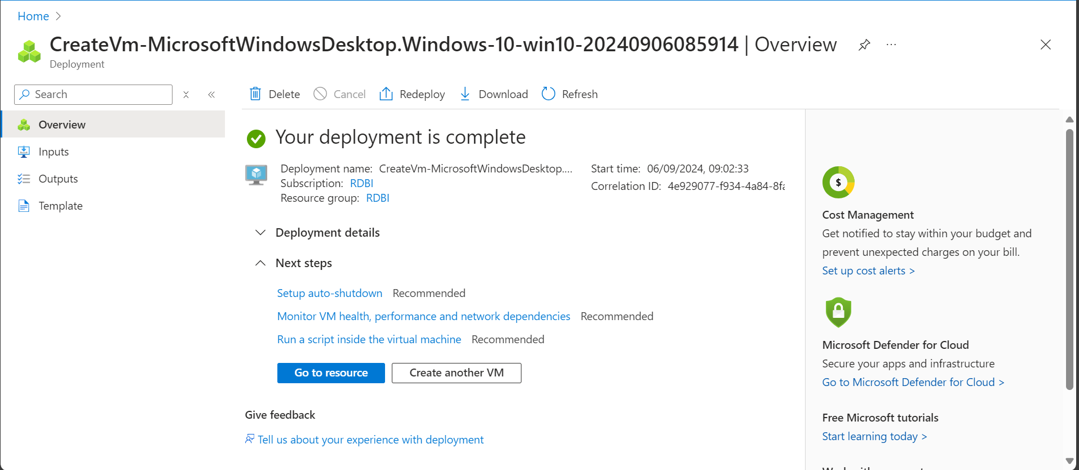

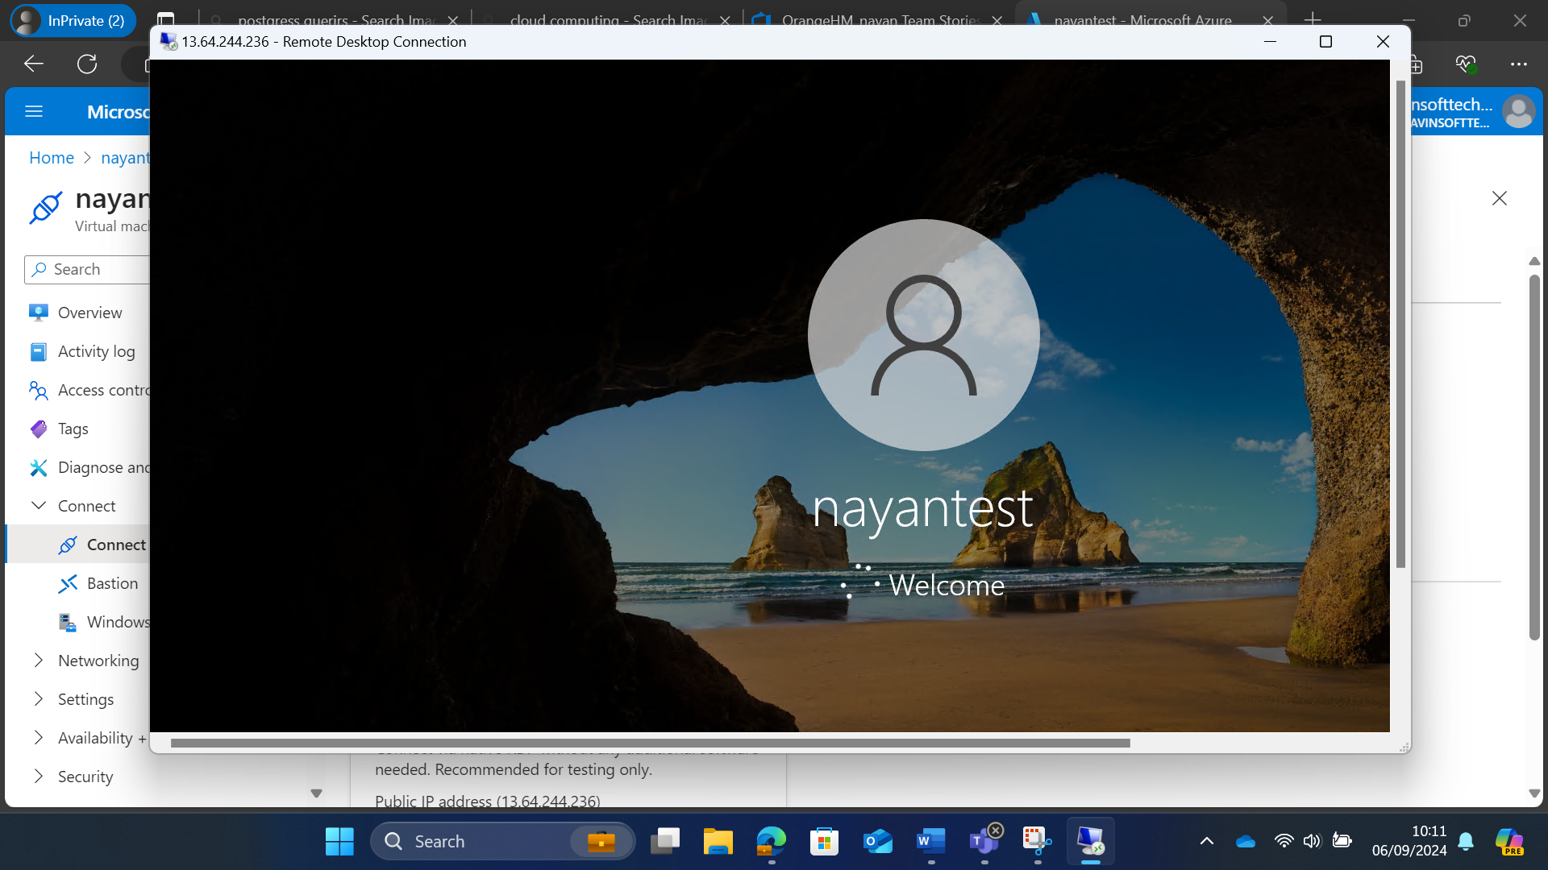

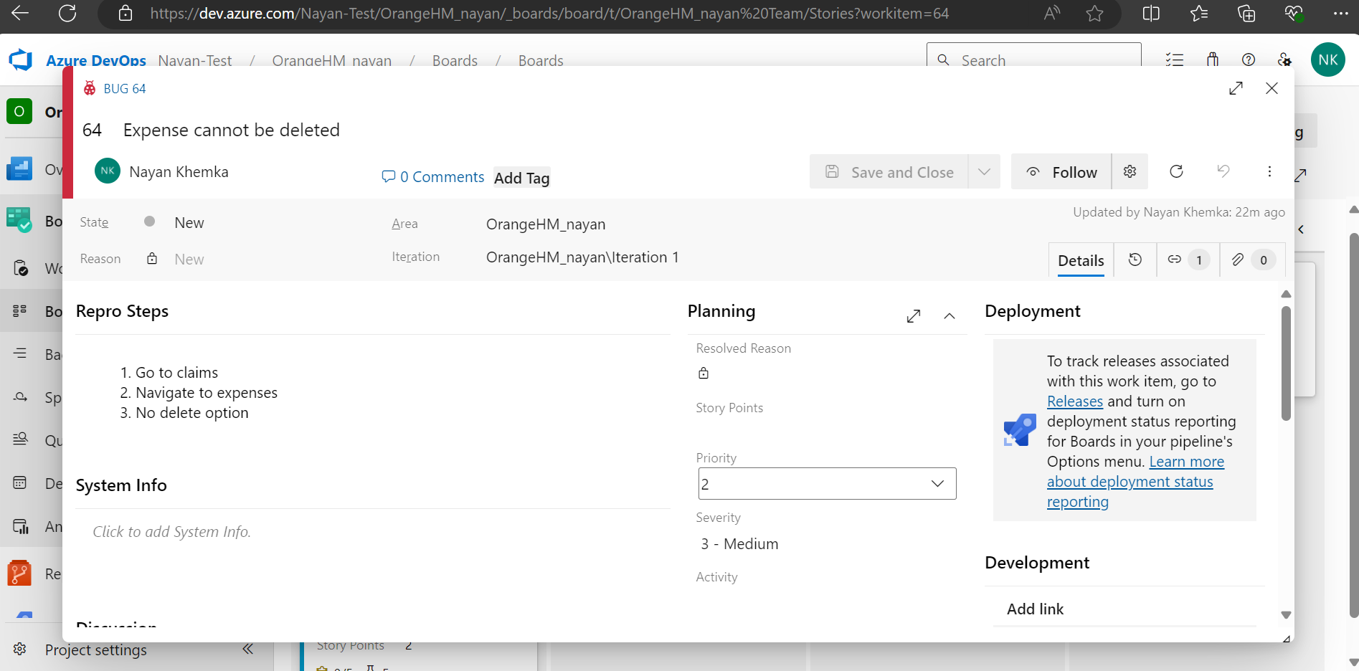

Bugs:

**TASK - 2**

The YAML file defines a **GitHub Actions workflow** for a Python application.

1. **Triggers**: The workflow runs on pushes and pull requests to the main branch.
2. **Job**: It has a single job named build that runs on the latest Ubuntu environment.
3. **Steps**:
   * **Checkout repository**: Uses the actions/checkout@v2 action to clone the repository.
   * **Set up Python**: Uses the actions/setup-python@v2 action to set up Python 3.x.
   * **Install dependencies**: Upgrades pip and installs dependencies.
   * **Run tests**: Runs unit tests using unittest.
   * **Deploy to GitHub Pages**: If all previous steps succeed, it deploys the application to GitHub Pages

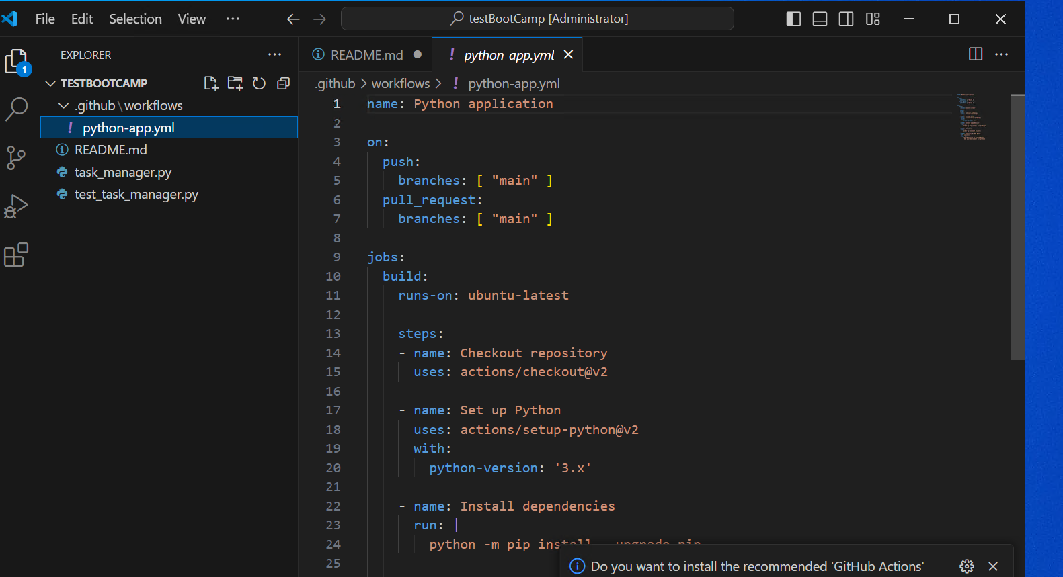

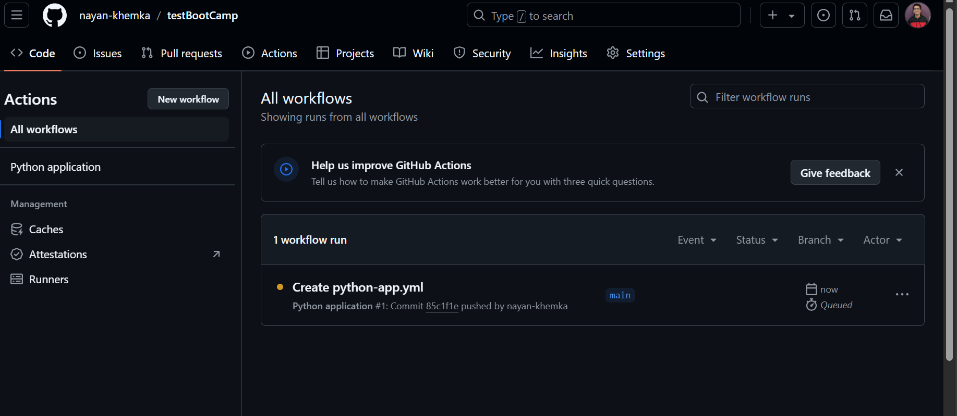

1. **test_add_task**: Verifies that a task can be added to the task list.
2. **test_add_empty_task_raises_error**: Ensures that adding an empty task raises a ValueError.
3. **test_add_non_string_task_raises_error**: Ensures that adding a non-string task raises a ValueError.
4. **test_view_tasks**: Checks that all added tasks are correctly returned by the view_tasks method.
5. **test_delete_task**: Verifies that a task can be deleted from the task list.
6. **test_delete_non_existent_task_raises_error**: Ensures that trying to delete a non-existent task raises a ValueError.
7. **test_add_multiple_tasks**: Verifies that multiple tasks can be added and viewed correctly.
8. **test_delete_multiple_tasks**: Ensures that multiple tasks can be deleted correctly.
9. **test_view_empty_tasks**: Checks that viewing tasks when the list is empty returns an empty list.
10. **test_delete_task_from_empty_list_raises_error**: Ensures that trying to delete a task from an empty list raises a ValueError.

[testBootCamp/.github/workflows/python-app.yml at main · nayan-khemka/testBootCamp](https://github.com/nayan-khemka/testBootCamp)